**Assignment No:-12**

Name:-Suryawanshi Sangramsingh Sambhaji

Batch: - Delta - DCA (Java) 2024 Date:-16/5/2024

**1. Write a program that takes in an integer and prints all the numbers from 1 to that integer, inclusive.**

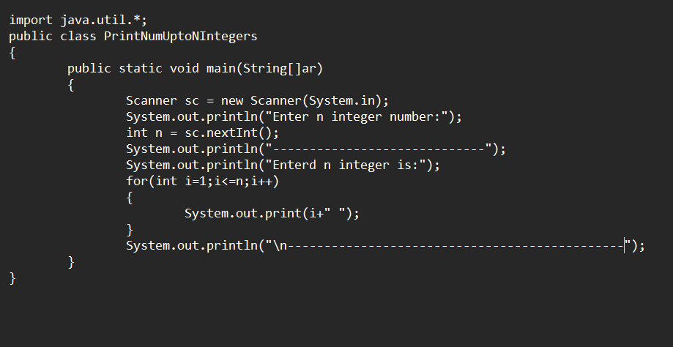

**Output:**

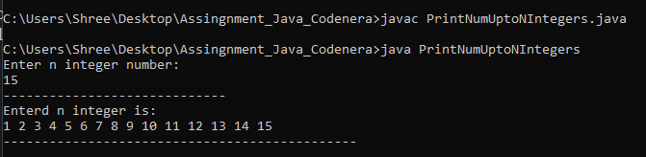

**2. Write a program that takes in an integer and calculates its factorial using a for loop.**

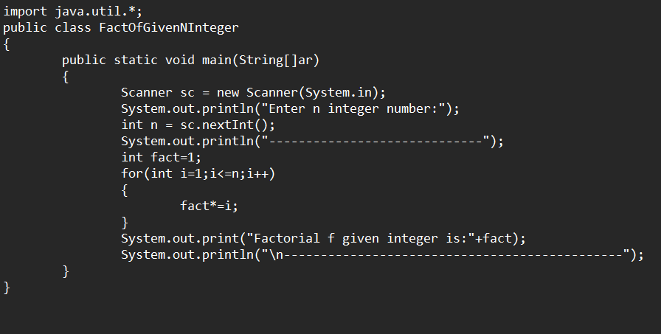

**Output:**

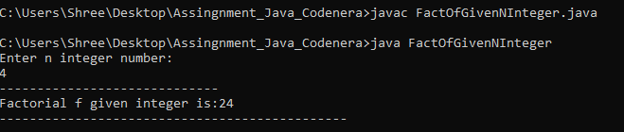

**3.** **Write a program that takes in an integer and checks if it is a prime number.**

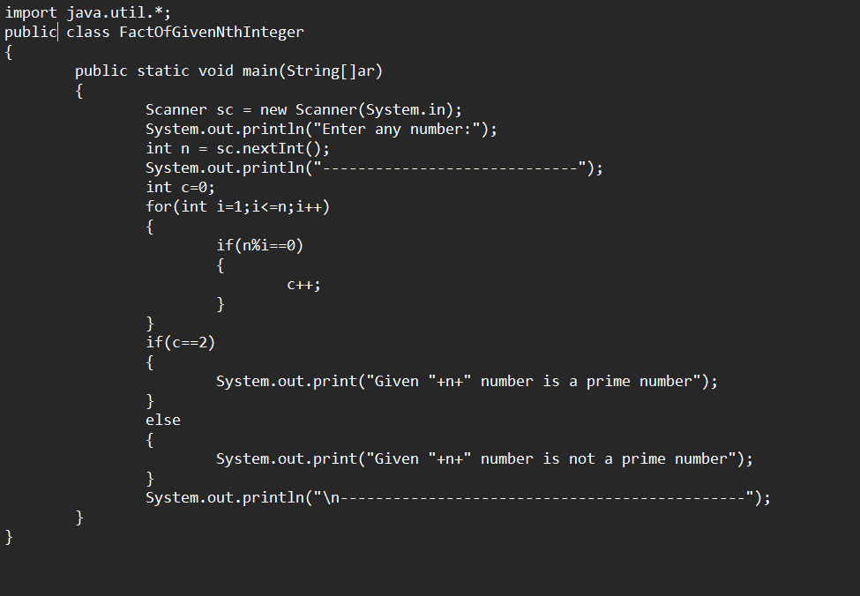

**Output:**

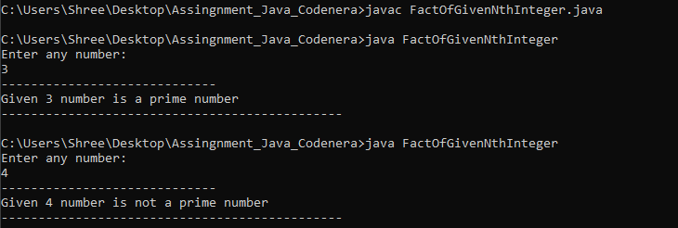

**4. Write a program that takes in an integer and prints all the prime numbers from 1 to that integer, inclusive.**

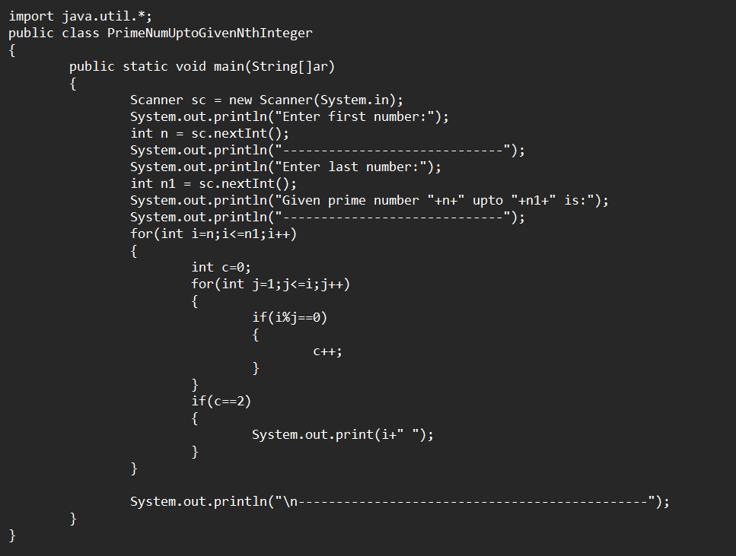

**Output:**

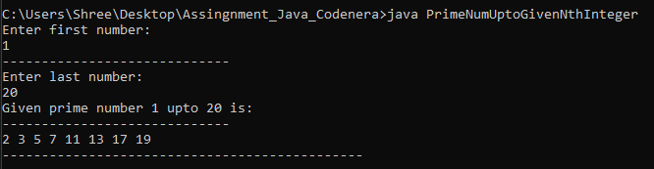

**5.** **Write a program that takes in an integer and prints a multiplication table for that integer up to a certain number of rows.**

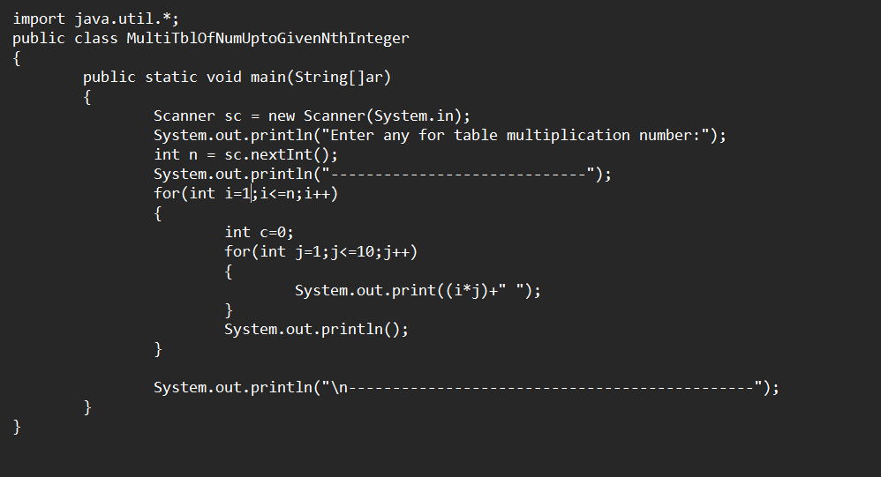

**Output:**

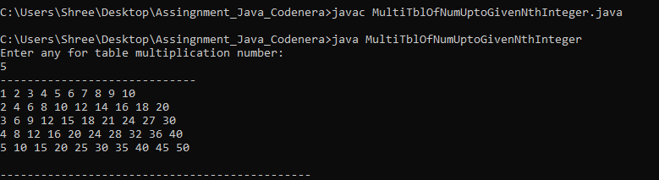

**6.** **Write a program that takes in two integers and finds their greatest common divisor (GCD).**

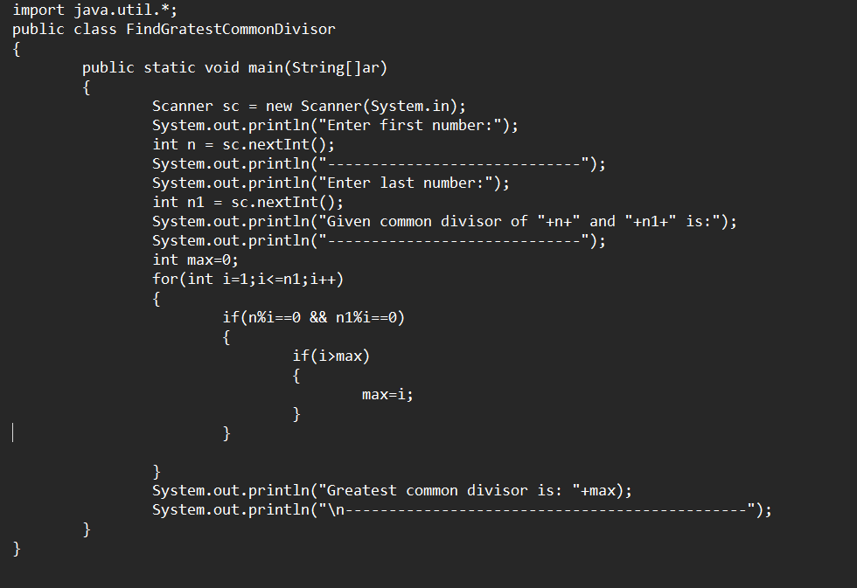

**Output:**

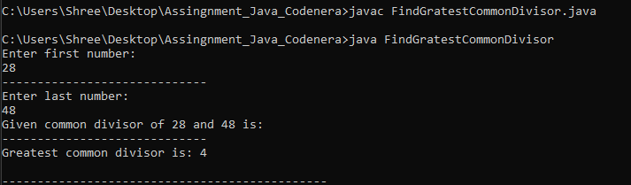

**7.** **Write a program that takes in two integers and finds their least common multiple (LCM).**

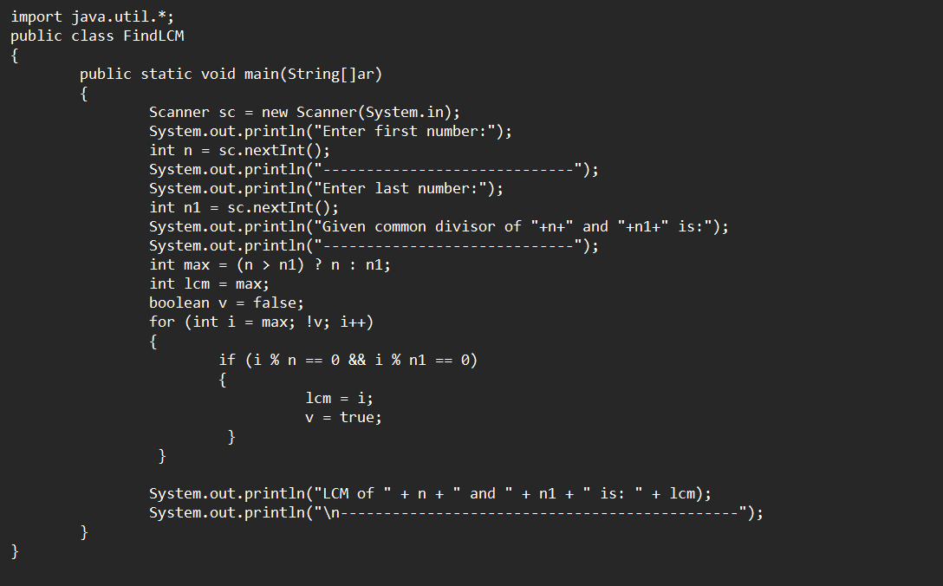

**Output:**

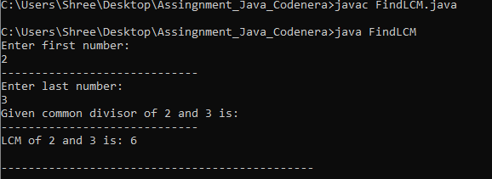

**8. Write a program that takes in an integer and checks if it is a palindrome.**

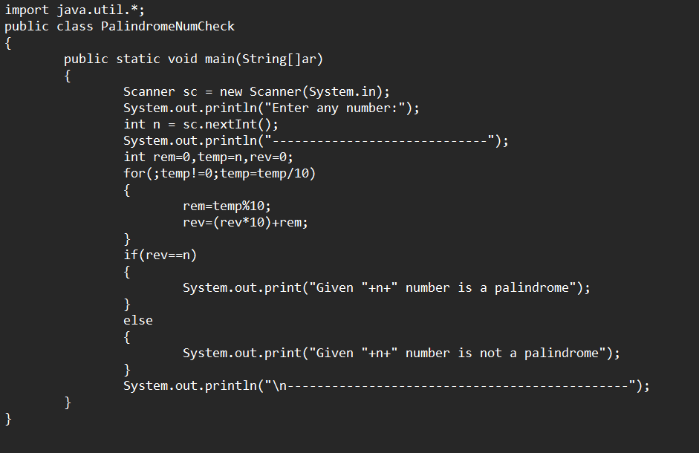

**Output:**

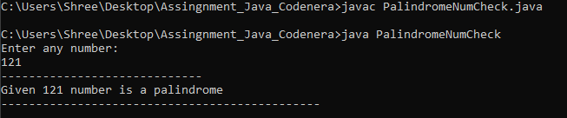

**9. Write a program that takes in two integers and uses the ternary operator to print the smaller of the two numbers.**

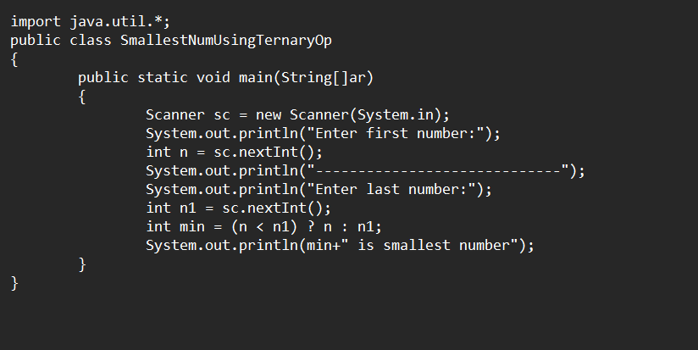

**Output:**

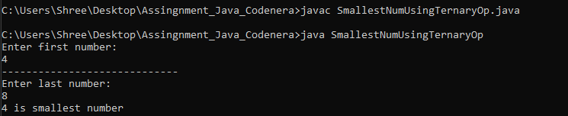

**10. Write a program that takes in an integer and uses the ternary operator to print "positive" if the number is greater than zero, "negative" if the number is**

**Less than zero, and "zero" if the number is equal to zero.**

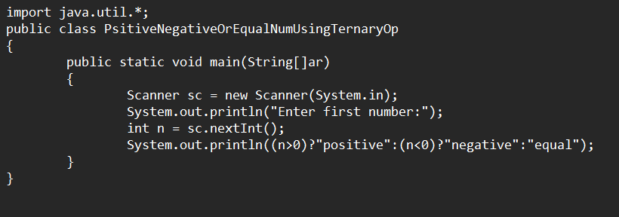

**Output:**



**11. Write a program that takes in three integers and uses the ternary operator to print the largest of the three numbers.**

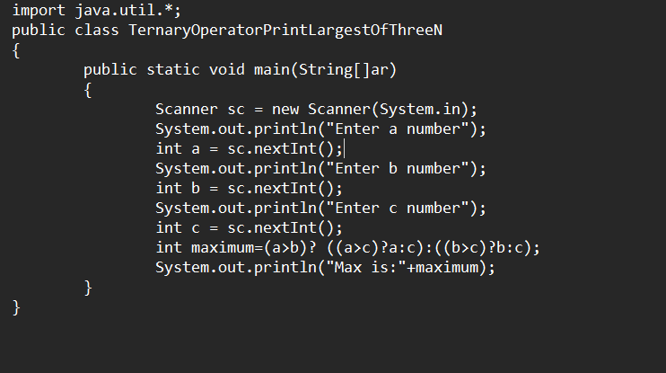

**Output:**

